NAME:KAVIYA VARSHINI P S M

REG N.O:192371007

17. Write a program to print all the composite numbers between a and b?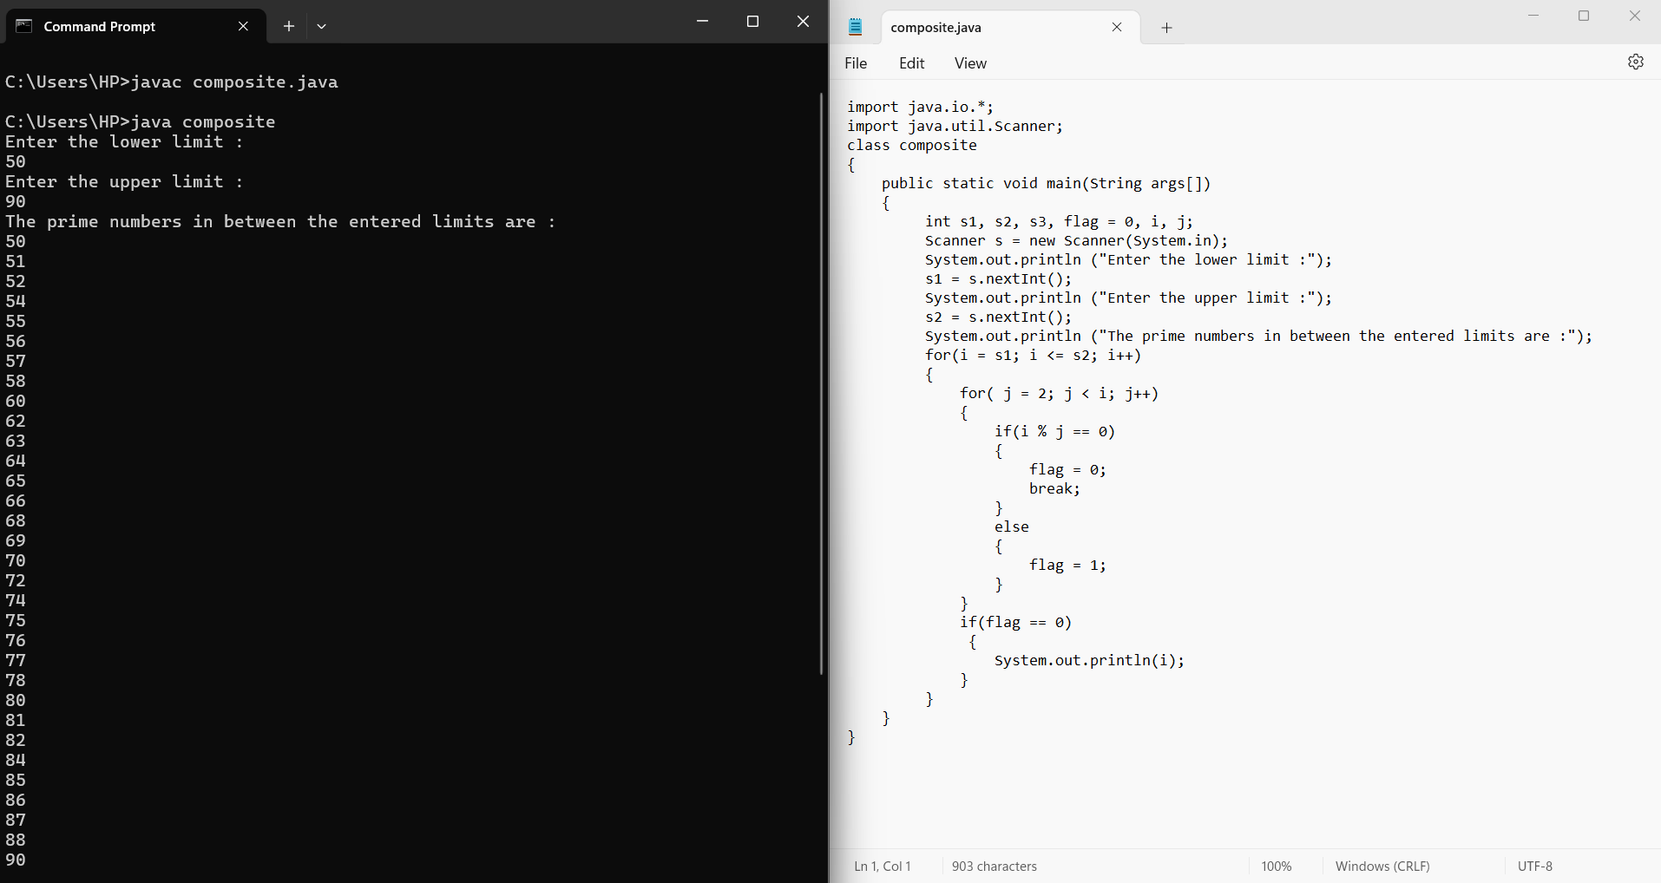

20. Find the factorial of n using while loop

Sample Input:

N = 4

Sample Output:

4 Factorial = 24

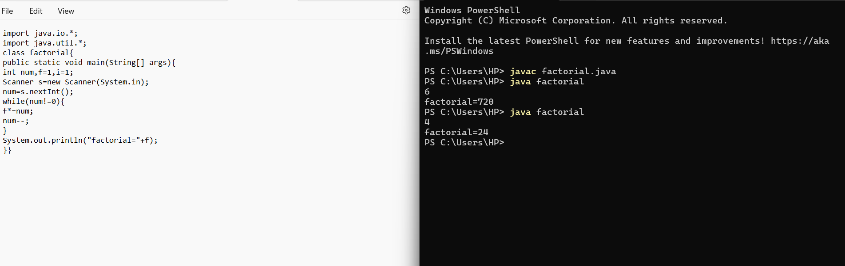

23. Find the number of factors for the given number

Sample Input:

Given number: 100

Sample Output:

Number of factors = 9

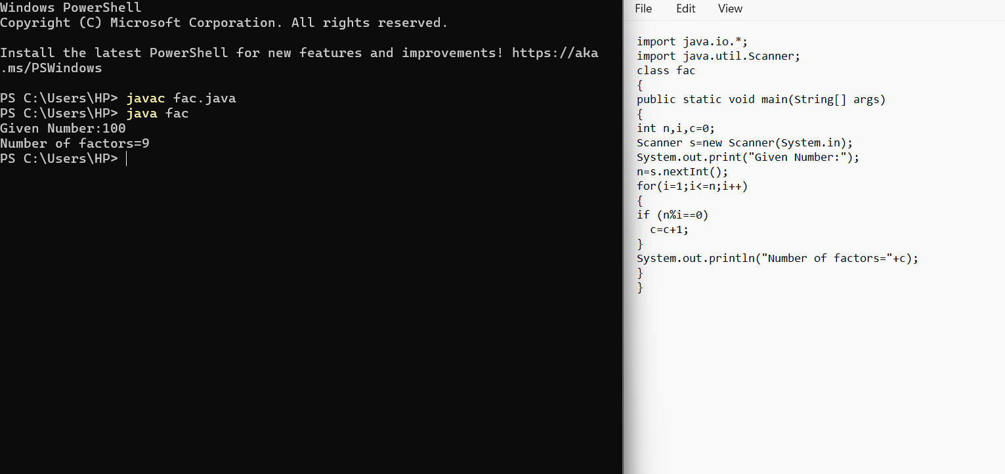

42. Write a program to find the square root of a perfect square number(print both the positive and negative values)

Sample Input:

Enter the number : 6561

Sample Output:

Square Root: 81, -81

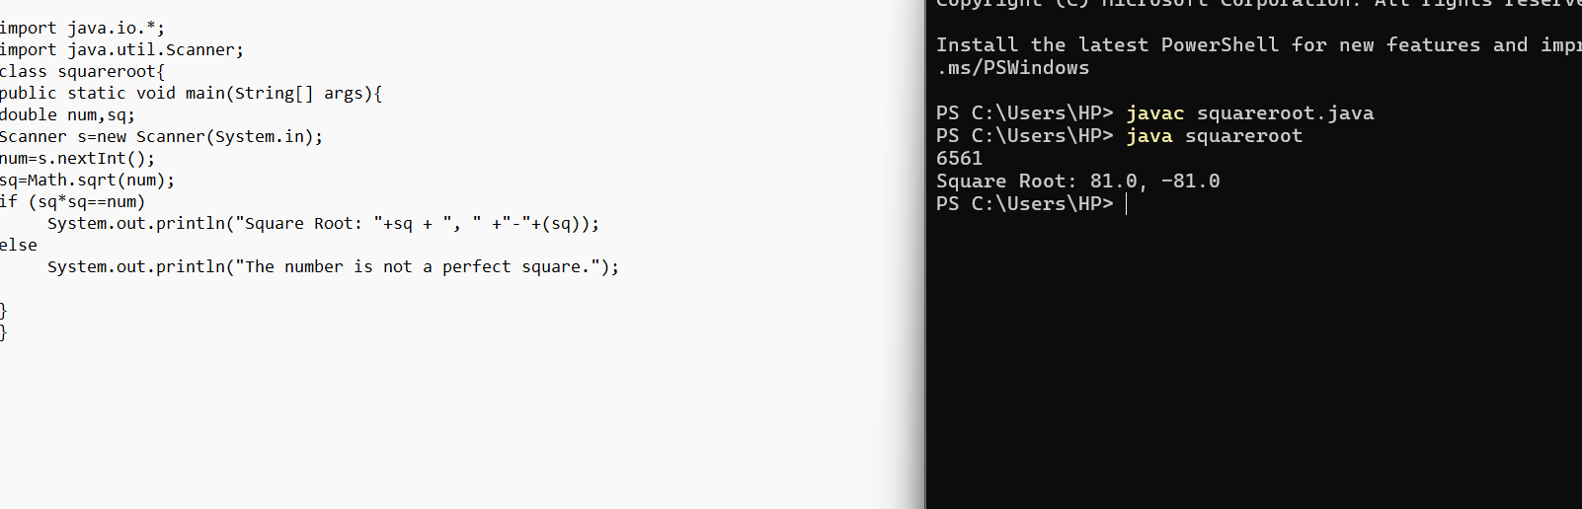

write a java code for perfect number for 4 digits:

